**Experiment 12: - Ansible Commands and Playbooks**

1. Check list of hosts.



1. Install httpd.

**Via ad hoc commands:**

Check in node



Install on server using ad hoc commands

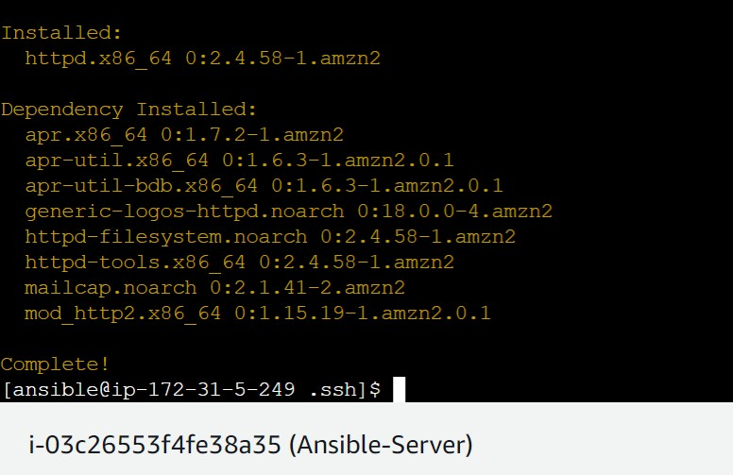

Now check on node machine.



1. Put public IP of node on browser and see Apache web page.

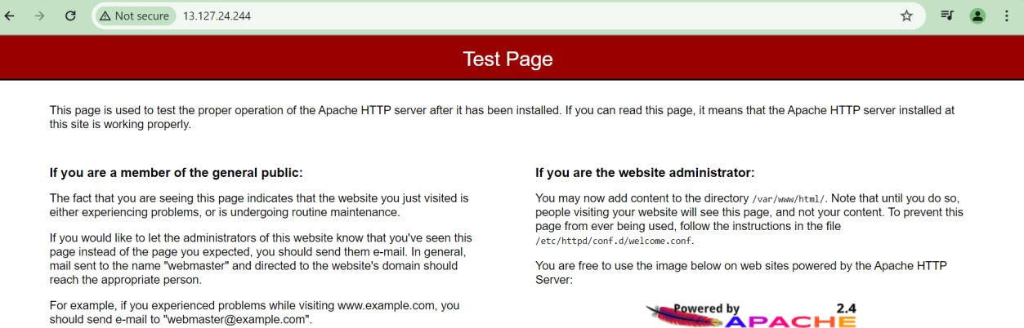

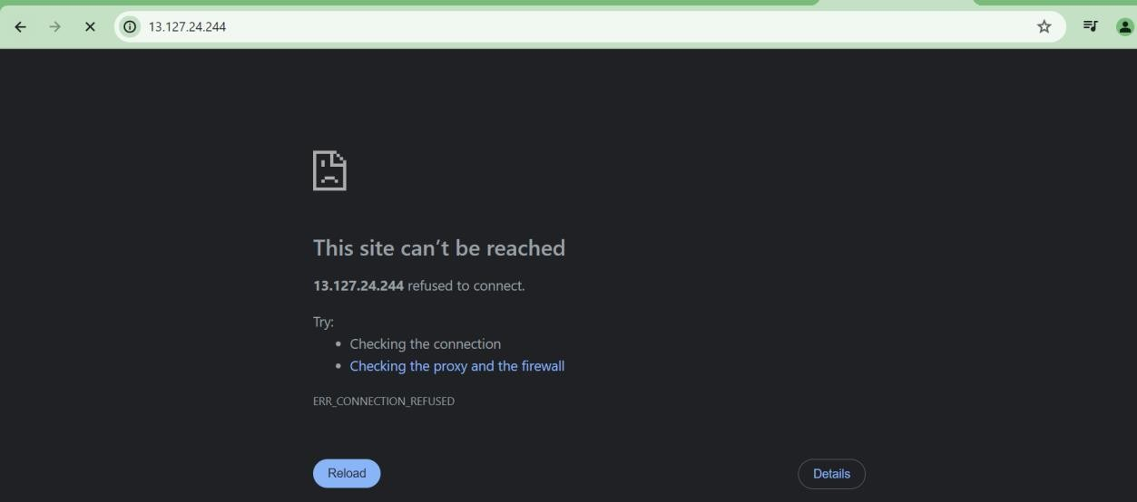

1. Via playbook

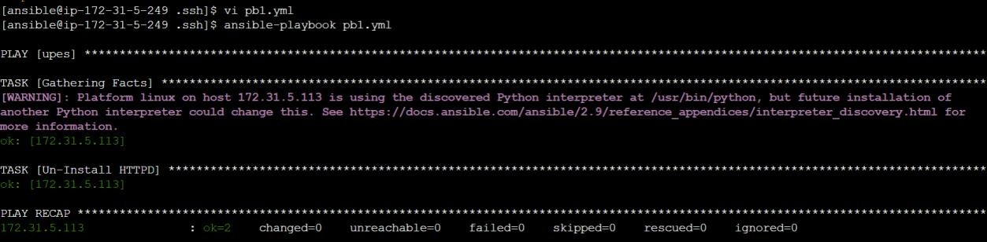

Sample playbook

---

- hosts: upes user: ansible become: yes connection: ssh vars:

pkgname: httpd currstatus: absent

tasks:

- name: Un-Install HTTPD

action: yum name='{{pkgname}}' state='{{currstatus}}'